Year 1 English Curriculum Map (2025-26)
 | Autumn 1  (3 days + 7 weeks) | Autumn 2  (7 weeks inc INSET day) | Spring 1  (6 weeks) | Spring 2  (5 weeks inc WBD 5.3.26) | Summer 1  (6 weeks inc BH/INSET day) | Summer 2  (6 weeks + TEST WEEK)
Fiction | Stories with a familiar setting  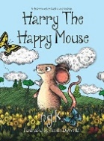  Harry the Happy Mouse  (LPDS Bridging unit) | Stories by the same author  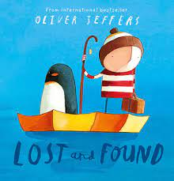  Oliver Jeffers  (LPDS Aut 1 ) | Story as a theme  Supertato  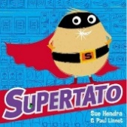  (LPDS Spr 1 Growth) | Story as a theme  The Highway Rat  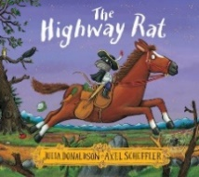  (LPDS unit) | Stories with fantasy settings  No -bot  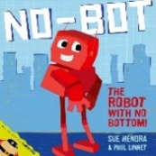  (LPDS Sum 2 Robots) | 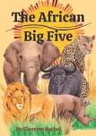  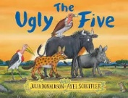  Talk Unit – The Ugly 5
Main outcome | Innovated story based on a plot pattern. | Narrative based on model text with innovation of character/s and setting. | Narrative based on model text with innovation of character(s) and setting. | Innovated story | A fantasy story featuring their own robot model as the central character. | Innovated story
Other short writing outcomes | Character Adjectives - sentences  What is Harry Thinking?  Thought/Speech Bubble | Sentence Writing – My Favourite animal  List  Question for the Penguin use ‘?’  List items for the journey | Describe a Setting  Create a Character – sentence writing | List of Foods  Sentence with ‘and’  Sentence with ‘!’ (e.g. Give me your puddings!)  Character description | Character Profile  Story map  Thought bubble  Question the Robot could ask. Use ‘?’ Use of question hand | Setting Description  Retell  ‘Or’ Sentences  List fruits
Independent | Innovated story based on a plot pattern -different animals | Innovate character or setting | Innovate character/setting | Innovate story – different choices | Innovate story | Innovate story
Non-Fiction | Non-Chronological Reports | Non Chronological Reports | Instructions | Non chronological reports | Recounts | Information Booklet
Main Outcome | An information poster focused on an animal | Information poster or booklet.(Penguins) | A simple set of instructions | Information page about rats | A first-person recount about making a model robot. | An information booklet on Africa
Other short writing outcomes | Write a question use ‘?’  Facts | Label- Penguin Diagram  Sentence Writing – Facts about Penguins | Collect Verbs – use in sentences  First, Then, Next, After – Making Jam Sandwich | Label a diagram  Fact file | First, Next, Then sentences about ‘Getting ready for School’ routine.  Recount of Robot’s journey around school. | Quiz Questions  Sentences using joining words ‘and’, ‘but’, ‘or’  Fact file
Independent | Information Poster | Information Poster  (Reindeer) | Instruction Writing | Information Page | Recount of Trip | Information Booklet
Poetry | Poetry, songs and rhymes |  | Nursery Rhymes | Poems on a theme  (Food)
Main outcome | Innovated poem based on a structure. |  | To enjoy and perform nursery rhymes with actions | Poem on a theme with a free verse structure  Oral presentation of the poem
Other short writing outcomes | Rhyming String  Peform  Simple Sentence Writing  ‘Mice Can…’ |  | Rhyming String | Food Adjective sentence
Independent | Poem |  | Retell Nursery Rhymes Story - props, puppets | Own food poem
Storytime | Hairy Maclary series | Animal Poems eg The animals went in two by two  Books by Oliver Jeffers | Supertato series | Traditional tales  Rapunzel, Rumpelstiltskin  The Princess and the Pea  The Elves and the Shoemaker, Snow White and the Seven Dwarfs, The Little Mermaid, Little Red Riding Hood | No – bot – the robots new bottom  Harry and the Robots  Robot poems | Peter Rabbit  Little Red Riding Hood and the Masai Warriors

